

Department of Computer Science and Engineering
Islamic University of Technology (IUT)
A subsidiary organ of OIC

Lab 02

CSE 4616: Wireless Networks Lab

Section: 2A
Semester: Summer
Academic Year: 2020-2021
Questions and Answer:
IP Addresses of Hosts:
- What is the IP address of PC1 of the subnetwork “Network1”?
Ans: 172.20.29.2
- What is the default gateway address of PC1 of the subnetwork “Network1”?
Ans: 172.20.29.1
- What is the IP address of PC2 of the subnetwork “Network1”?
Ans: 172.20.29.3
- What is the default gateway address of PC2 of the subnetwork “Network1”?
Ans: 172.20.29.1
- What is the IP address of PC3 of the subnetwork “Network2”?
Ans: 10.10.29.2
- What is the default gateway address of PC3 of the subnetwork “Network2”?
Ans: 10.10.29.1
- What is the IP address of PC4 of the subnetwork “Network2”?
Ans: 10.10.29.3
- What is the default gateway address of PC4 of the subnetwork “Network2”?
Ans: 10.10.29.1
- What is the IP address of PC5 of the subnetwork “Network3”?
Ans: 192.168.29.2
- What is the default gateway address of PC5 of the subnetwork “Network3”?
Ans: 192.168.29.1
- What is the IP address of PC6 of the subnetwork “Network3”?
Ans: 192.168.29.3
- What is the default gateway address of PC6 of the subnetwork “Network3”?
Ans: 192.168.29.1
Screenshot of the routing table of the Routers:
- Add a screenshot of the routing table of Router0 of the subnetwork “Network1”.
Ans:
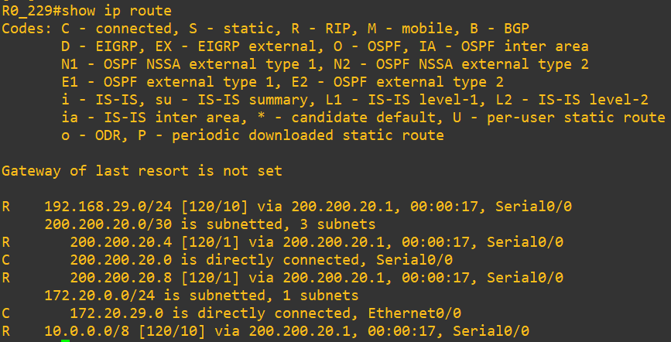
- Add a screenshot of the routing table of Router1 of the subnetwork “Network2”.
Ans:
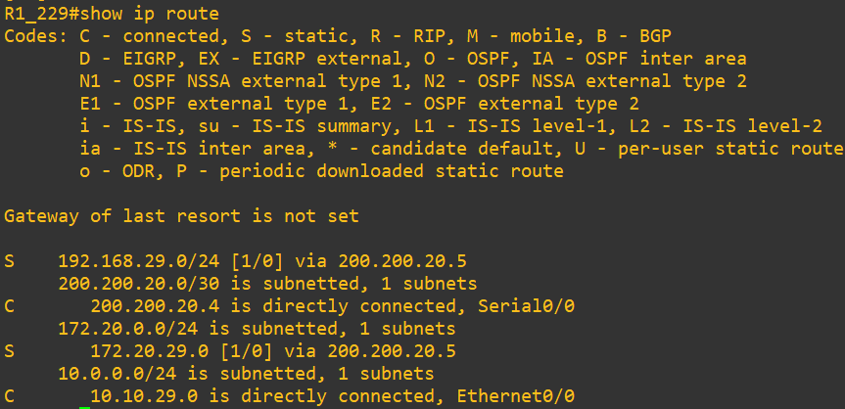
- Add a screenshot of the routing table of Router2 of the subnetwork “Network3”.
Ans:
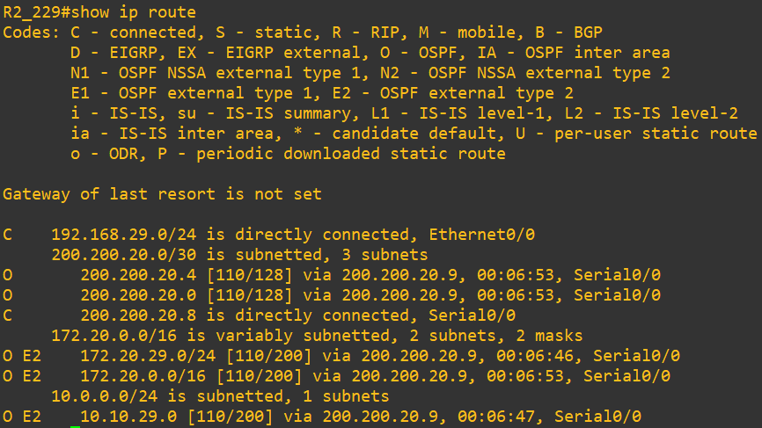
- Add a screenshot of the routing table of the Core Router.
Ans:
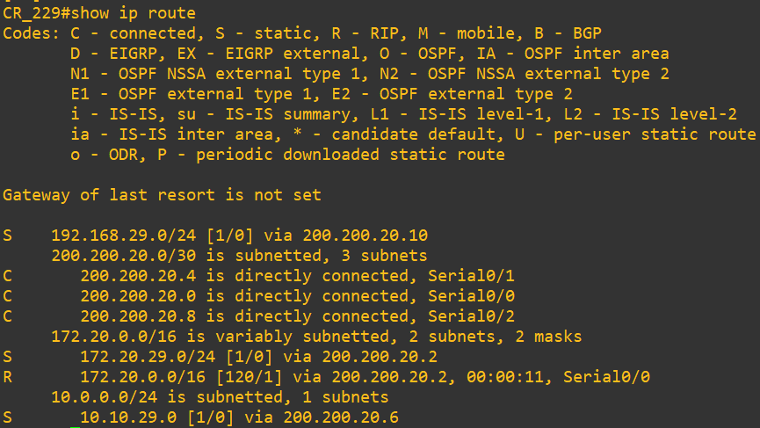
- Add a screenshot of the complete topology with proper labeling after configuration.
Ans:
